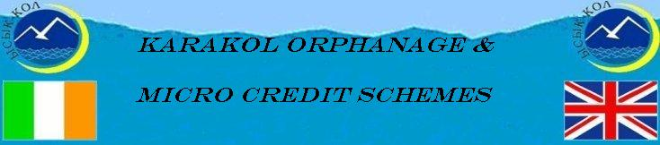

Update May 2010

Introduction
Yet Another Kyrgyz Revolution
We are sure you have all heard that Kyrgyzstan has recently been in the world news for all the wrong reasons – yet another revolution with tragic loss of life and wanton looting of shops and stores on a massive scale. This is the second time in five years there has been a revolution, each time the incumbent President fled the country and a new regime took over. This time the trigger for the demonstrations was the dramatic increase in energy prices though the sluggish economy and the underlying corruption, also contributed to the unrest. Mass demonstrations were organised around the country and then on the 7th April these demonstrations moved to Republican Square and the seat of Government, the “White House”, in Bishkek. As Hugh’s office overlooks Republican Square he had a grandstand view of the demonstrations but when the shooting and explosions started he beat a hasty retreat to our flat some two blocks away. It certainly was a very scary few days as shooting and looting continued until gradually the new regime took control and order was restored again.
Five opposition parties make up the new regime with Roza Otunbayeva elected Head of the Interim Government and recently Interim President. She is a very experienced politician/administrator, having been a former foreign Minister and Kyrgyz Ambassador to United States and Canada and later to United Kingdom so she comes to the position with excellent local and international experience. Another new constitution is being prepared for a June referendum and new elections are now planned for late 2010. Hopefully this new regime can bring much needed stability to Kyrgyzstan and get the economy back on track. The state of the economy can be illustrated by a World Food Programme survey carried out in 2008 found that 35% of households were food insecure, with 21% of total population being severely food insecure.
Karakol Orphanage
At the start of the year there were 21 children being looked after at the home but in subsequent months 6 children were returned to their families. Presently there are 16 children as a thirteen year old girl who was found in the street in Karakol was taken by police to the home and is now being looked after by Chynara and her band of volunteers. The police are good supporters of the orphanage and make regular visits, usually bearing presents for the kids.

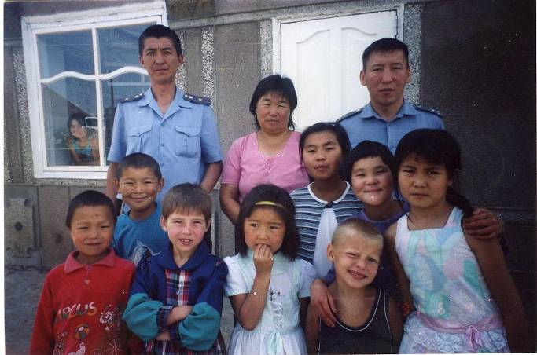
Police visiting the children

The children celebrated Victory Day by going to the theatre and presenting some of the Kyrgyz heroes with flowers.

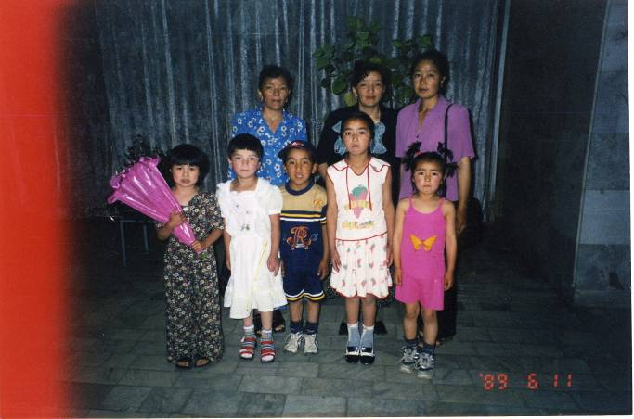
Chynara and her team have been supervising or planning projects. The first project was completing the security wall around the new livestock building which was started in autumn. As you can see from the picture it is a massive wall constructed of blocks made from waste slag donated by the nearby heating plant, sand provided by the Deputy Governor of the Region and cement purchased from our funds. Security gates need to be fabricated to complete this very impressive livestock compound.

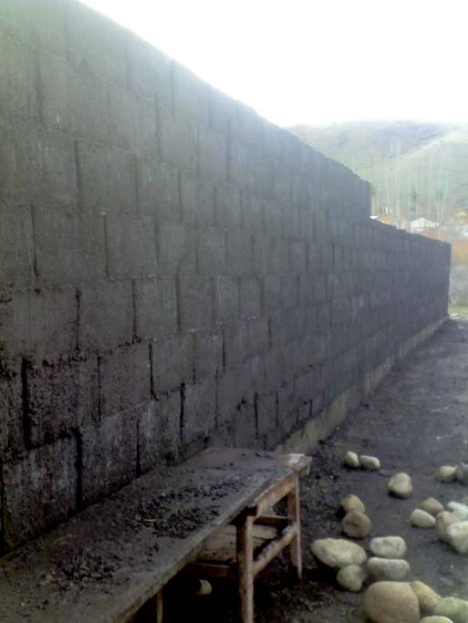
Built using funding provided by Navan Lion’s Club in Ireland

Another project is the reseeding of the 5 hectares of grassland to provide hay for winter feed for all the livestock using funds donated earlier this year by various sponsors. This will be completed by early June and we are looking forward to several excellent cuts of hay this year.
Another local sponsor offered half a hectare of irrigated land rent-free for vegetables and as we write this newsletter cabbage, beetroot, carrots, garlic, onions, tomatoes, cucumber, lettuce and potatoes are being planted. Again this is being funded from donations from our sponsors. However, the rent-free aspect did not materialise as the local sponsor was moved from his position after the revolution so we ended up having to pay for the rent.

Microcredit
Presently 58 clients, including several groups, are being funded under the two schemes, Tumar Microcredit and Development Microcredit Agency. Total funds provided to these two microcredit organisations are Euro 13,450 and loans vary from about Euro 100 to Euro 500 per client. Each month these agencies have been providing us with monthly reports on loans, including repayments, interest payments, what each loan is being used for and any problem areas. However, as these schemes are operating very effectively we have suggested that only quarterly reports are required in the future to ease the administrative burden.

Karakol Micro Business Fund – Tumar
Tumar was formally established in 2007 by Hugh’s former project staff in Karakol with approval of the National Bank of Kyrgyzstan and the Ministry of Justice. Presently the credit portfolio is 263,551 som with 157,551 som funding the 18 business clients (commercial) and 106,000 som funding the 17 social clients.
The Manager of Tumar, Kuba got married in March and we would like to wish both his wife and him a very happy life together.

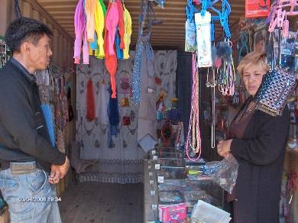
Arsen (Tumar) with client running children’s book and craft store at Karakol Market.

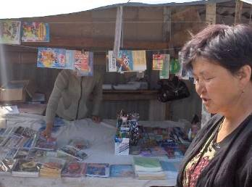

Another Tumar client at Karakol Market who runs stationary store

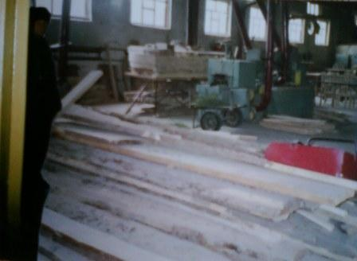
Karakol Micro Business Fund –Social Fund Microcredit Agency “Development”.
We have been funding Development Microcredit Agency since October 2007 but at this time this Agency was already formerly established by Sonun Teltaeva using her own funds. Our funding has allowed Sonun to expand her women clients and diversify significantly the activities funded. Presently there 23 clients including sewing/knitting (3), trading (7), livestock (7), crops, including one garlic grower, (4) and bakery (2).

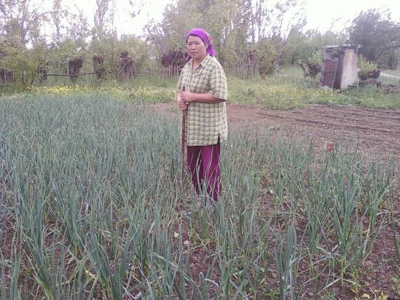

Sultanbekova Baktygul received a loan for garlic production

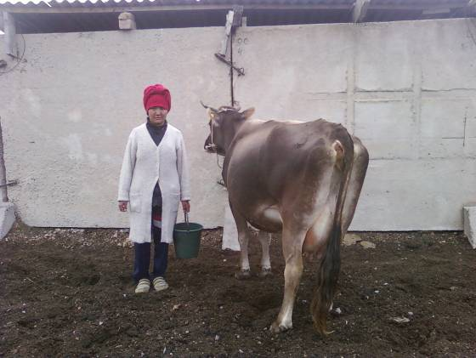

Monolova Guljan received loan for cow purchase

Sonun had previously worked with Hugh’s EC Tacis Project in Karakol and she was renowned for her enthusiasm and hospitality. She hasn’t changed and she is an amazing bundle of energy and her hospitality knows no bounds!!

Dyuweeva Aygul runs a family welding business involved in the production of stoves and boilers using both electricity and coal

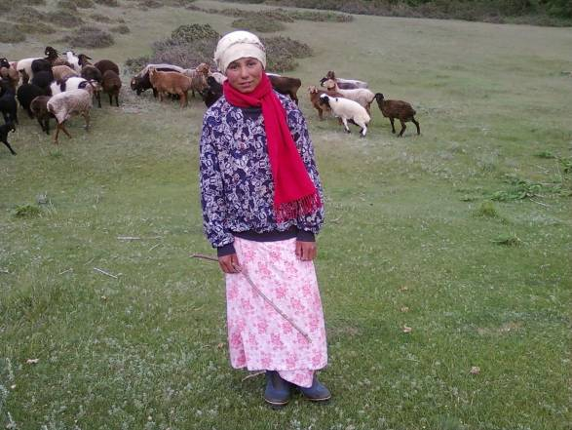

Amanova Malika loan for sheep rearing

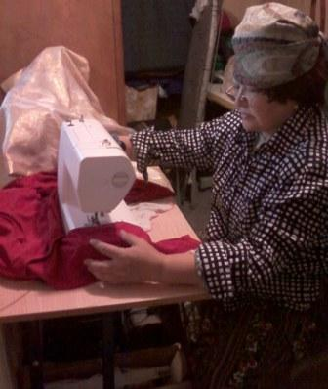

Tologonova Gulnaz
Loan for development of dress making business

STOP PRESS

A Flute Recital for Karakol Projects is being held by Catherine Coulter Young

Saturday 19th June 2010

ST MARY MAGDALENE’S
MUNSTER SQUARE
LONDON NW1 3PT

7.30PM

Music to include works by Faure, Harty and Liebermann

Cost £10

www.marymagdalenes.co.uk

If you or anyone you know is in London this weekend Catherine would love your support.

Many thanks Catherine for organising this event on behalf of the Karakol Projects and it is greatly appreciated.

Following is the update on our recent sky diving event – it was a great success as you will see from the following report and photos. ENJOY

Fundraising Event 2010

Saturday 22 May, Irish Parachute Club, Co. Offaly, Ireland
And New Zealand
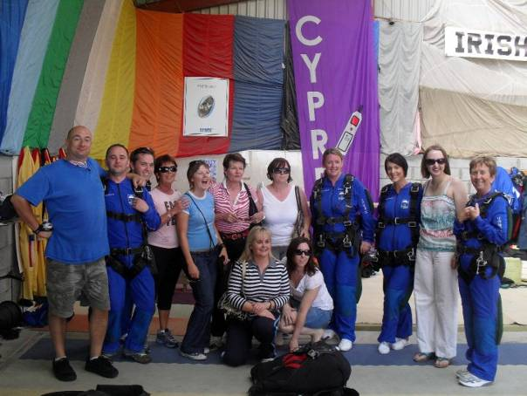

Our sincere thanks to all the brave sky divers who participated in this fundraising event:
Ian Murray, Adrienne Lennon, Fran Ford, Joan Byrne, Lynn Gaffney, Helen McClean, Samantha Morgan, Anna Smith, Annmarie Maguire, Jennifer Coulter, Roisin Coulter, Yang Han, Natalie Palmer, Kimberley Gibson and Jean Coulter. We could not have done this without you all. We would also like to extend our gratitude to everyone that fundraised and sponsored on behalf of the Karakol projects. Money is still coming in; however, the total should be in excess of €6,000. Well done to one and all.
The highly anticipated day had come upon us – it was D-day for the 15 mad volunteers to throw themselves out of a plane and leave their lives with the mercy of the gods. Thankfully the day had the most perfect conditions for skydiving – the sky was clear of all clouds and the sun was shining down upon us.

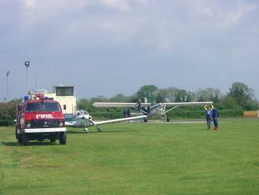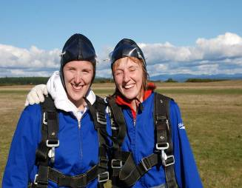

Ready, Steady, GO!!! Kimberley Gibson & Natalie Palmer
Jumping in New Zealand

The 13 Irish skydivers and their teams of supporters arrived at the Irish Parachute Club in Clonbullogue, Co. Offaly, having already heard that the New Zealand skydivers had successfully completed their jumps just outside Auckland. Once the skydivers had all assembled, we registered and signed the waivers (admitting our
own liability if we were to injure ourselves, or worse!!)
While we all waited for our turn to suit up and jump, we watched as those already before us fell from the sky above. There were solo jumpers, tandem jumpers and even some old world war veteran parachutes cascading from the sky. First to be suited and booted was Roisin and her Mum, Jean Coulter.

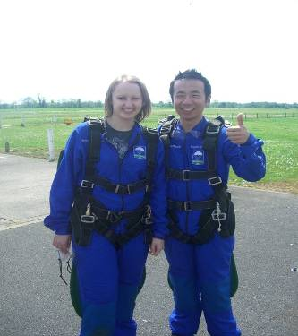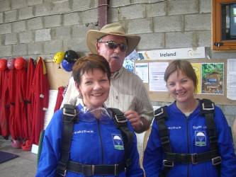
Jennifer & Yang Jean, Rois & Hugh

We were all assigned a tandem jumper, a very becoming jumpsuit and given our instructions on what to do. Remember ‘head back, arms crossed, and legs back’. Roisin was even told as it was her second jump that she would be pulling her own chute and doing more of the steering. After the plane had refuelled we boarded the tiny plane and started the ascent to 10,000 feet.

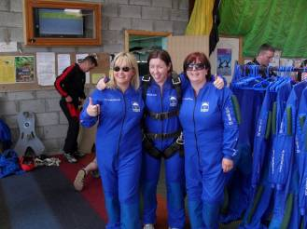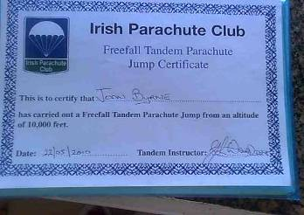
Samantha, Ann & Annmarie Joan’s Certificate!!!!!

Once high enough, the plane started tilting the passengers out, each one disappearing and falling about 120 miles per hour down. There really are no words to describe the feeling of freefalling, there is just an amazing sense of peace. The natural high
that you get from falling from the sky is amazing. As the day progressed, more and more volunteers began to fall from the sky and return to solid ground, in body at least. Every jumper was greeted by cheers and all returned with big smiles on their faces, declaring that they would jump again! The day was ended on a high and with the much needed celebratory drink and meal.

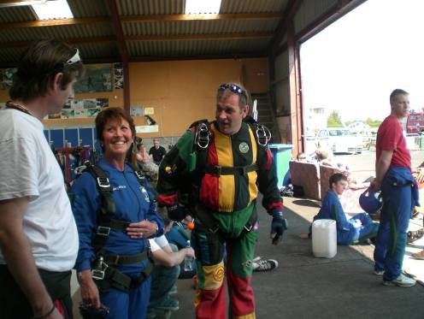
Joan & her sky dive Master John

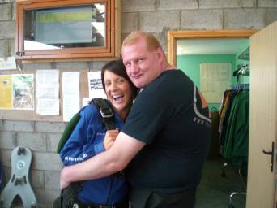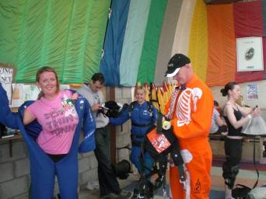
Helen and Lynn getting ready for take off!!!
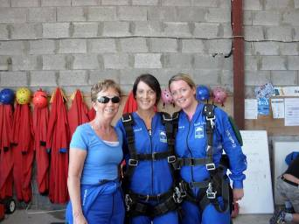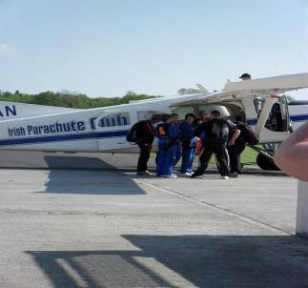
Adrienne, Helen & Lynn ready for takeoff!!!

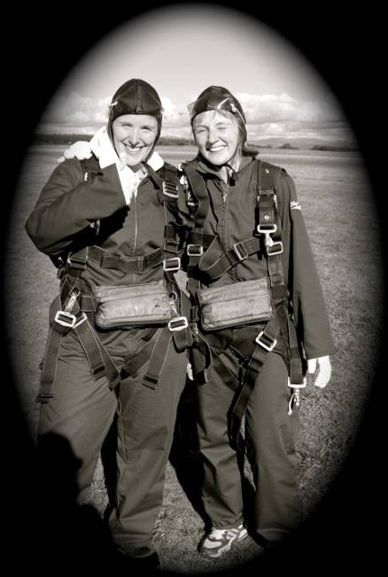
A wonderful old style shot of Natalie and Kimberley, New Zealand

A FEEL GOOD STORY!

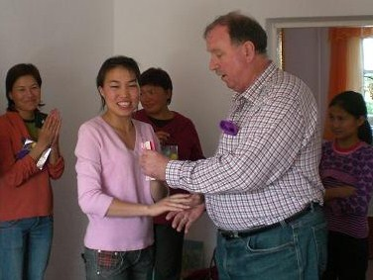
Bermet with Hugh

Bermet is Chynara’s daughter and has been not only helping to look after the children over the past 6 years but has also acted as interpreter for Hugh and myself over the past number of years. Last year Bermet asked us if we could fund a TEFL course to enable her to improve her English and to assist her in getting study or work opportunities overseas. We were more than happy to help Bermet with this opportunity.
When we were back in Karakol in March Bermet told us that not only had she done very well in her exams but that there were scholarships to be awarded to the two best students. We have just heard that Bermet was indeed one of the top students and has been offered a 10 month scholarship to study at a university in Turkey. We are all extremely proud of Bermet’s achievement and know that she will make the very most of this opportunity. Congratulations Bermet, you’re a star.

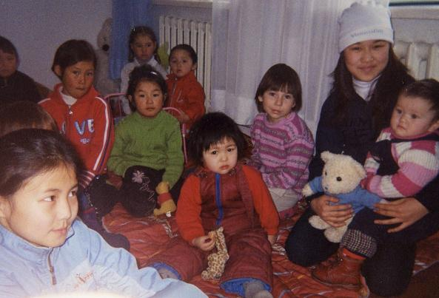
Some of the little darlings!!!

Projects under consideration for 2010
- Additional funds for the micro credit schemes to make them more sustainable
- Ongoing operation costs
- Purchase of more animals
- Study Room – more chairs and 3 storage units still to be financed.
- Signage outside the orphanage and other signs on nearby roads
- Purchase of suite of furniture for the playroom
- Two solar systems to reduce electricity and heating bills
Caution is being used regarding expenditure due to our ongoing concerns regarding finance of food requirements and medical costs for Jyldyz & others.

Last word
Following the more recent unrest in the South of Kyrgyzstan we are still unsure as to when Hugh will be returning. However, our work will continue with the Orphanage and Micro credit projects. Given these very turbulent times in Kyrgyzstan it will be even more important to support these projects as life for one and all will be all the more difficult.
With your help we can make 2010 an even better year for the Children and so many people who rely on the funds from the MicroCredit Projects.

Once again sincere thanks to all of you who supported and took part in the Sky Diving Event.
We would like to thank all who have continued to support us as well as new contributors to these very worthwhile humanitarian projects. Without you all none of this would be possible.

Contact Details
Further enquiries and details can be obtained by Emailing: hugh.coulter@gmail.com or
Writing to: Hugh & Jean Coulter, Mourne View, Coolfore, Monasterboice, Drogheda, Co Louth, Ireland or
Telephoning: 353 (0) 41 9826819
Mobile: 353 (0) 87 2740607
Bank Details Bank A/c: Karakol Orphanage A/c
Ulster Bank,
104 West Street, Drogheda, Co. Louth, Ireland
A/c No. 13403018
Sort code: 98-55-65
BIC: ULSB IE 2D
IBAN: IE03 ULSB 9855 6513 4030 18

