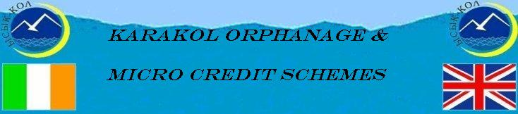

Update January 2011

Introduction
Once again it is time to review our financial activities for the past year and to outline some of our plans for 2011. First and foremost we would like to sincerely thank all our sponsors and donors, both international and local, for their generosity during 2010. During 2010 with your help we raised Euro 15,589 (compared with 11,292 in 2009), and together with carryover funds from 2009 a total of Euro 17,785 (compared with 17,297 in 2010) was available for Orphanage and Microcredit activities. We would like to give special thanks to the Navan Lions Club for their continued support to making the orphanage more sustainable through expansion of the livestock project, to Ian Claytor of Celestial Mountain Tour Company for his regular donations, to KMK Metal Ltd, Kurt and Edeltraud, to our ‘French Connection’ of Nicolle, Joelle and Denis for their ongoing generous support, to Hugh’s brothers and sisters and their families who have donated funds to our Karakol fund instead of giving presents to each other, and to other regular sponsors friends and colleagues for their amazing generosity, namely Frank, Simon, John and Ursala.

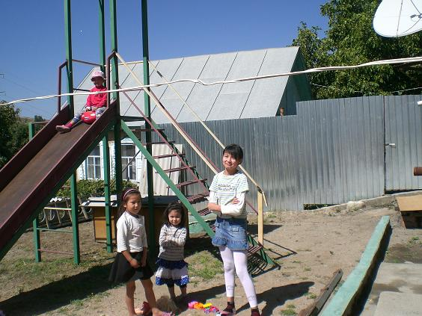
Some of the kids at play

A huge thanks to all who were involved in our fundraising events – “the intrepid skydivers” and niece, Catherine, for “the magical flute extravaganza”. We are also very grateful to local sponsors and donors in Kyrgyzstan, specifically the Children of Tien Zhan Fund for their continued support, but also to numerous Karakol companies and individuals that contributed more often in kind in terms of school bags and foodstuffs and such like.

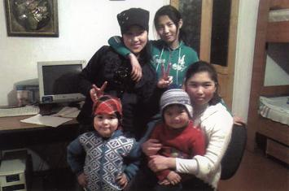
Well dressed children in their Kyrgyz gear

Of the total funds available we allocated Euro 7,998 to the orphanage, Euro 4,954 for operating expenditure, Euro 2592 for mini-projects and Euro 453 on miscellaneous expenditure including transport, bank charges and translations. In addition a loan of Euro 500 was provided to Bermet, daughter of the Director and one of the long standing carers at the orphanage, to cover initial costs of her overseas study cost until she received her grant.

A total of Euro 500 was allocated to the Microcredit scheme ICK Microcredit. Tumar was going through a downsizing process, given that the two key staff were made redundant, one as a direct result of the April revolution, and were very actively looking for new employment which could involve them moving away from Karakol as job opportunities are virtually non-existent. Due to the downsizing of Tumar Euro 1800 of their funds was transferred to ICK Microcredit.

At the end of the year there was a balance of Euro 8,787 which is carried over to 2011 to continue our activities.

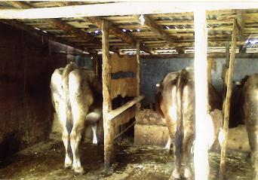
Cow, Heifer and Bullock in the Byre during winter

Orphanage key achievements of 2010 were the caring of between 11 and 21 children each month, completion of the livestock complex, including massive security gates, high security fence and one unit has been converted for living quarters for security purposes, that now houses all the animals during the winter - cows, calves, sheep and goats and thus facilitating the expansion of the livestock project, roofing part of the hen run to provide protection from snow during the winter, and concreting outside the playground area and concrete paths to the henhouse and livestock complex. In addition all the windows on the first and second floor have been replaced by new doubled glazed windows, apart from the glass of the former windows which has been recycled. Microcredit key achievement was the funding of over 70 microcredit mini-projects during 2010.

Karakol Orphanage
In this edition we would like to report on how the funding was spent on orphanage activities during 2010. Of a total Euro 7,998 funding of the orphanage Euro 4,954 (66%) was spent on operational expenses and Euro 2592 (34%) on mini-projects. The major operating expense was food at 72% of operational expenditure, followed by medication 13% (for epilepsy treatment of Jyldyz), washing/cleaning items at 5%, gas at 4%. electricity at 3%, and telephone 3%.

Orphanage mini-projects funded during 2010 included the following: completion of the livestock complex including huge security gates, fence and security room (27% of total mini-project funds), in-calf heifer (20%), reseeding hay field (15%), coal for the winter (14%), roofing over hen run (8%), vegetable garden (8%), concreting paths (7%) and installing new telephone line (1%). Miscellaneous expenditure was Euro 453 transport, bank charges and translations.

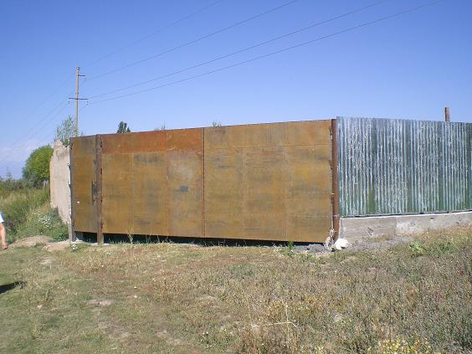
Huge security gates to livestock complex

As mentioned in the introduction a loan of Euro 500 was provided to Bermet, the Orphanage Director’s daughter, to cover initial costs of her overseas training until her grant became available. These funds will be repaid at the end of her overseas training in June 2011.

The number of children being looked after during 2010 varied from 11 (November 2010) to 21 children (January 2010). Ten kids were returned to their parents or relatives during the year – the reasons for being taken in in the first place may be due to parents looking for work and are so poor cannot look after their kids properly or in some cases leaving the kids with elderly relations while the parents go to work in Russia or Kazakhstan but then the relatives find they cannot cope because of sickness or lack of money so they asked Chynara to look after their children. Seven additional children were brought to the orphanage during 2010. Since the orphanage started it has catered for more 260 children cared for in this manner.

The charity organisation Children of Tien Chan has provided lots of bags of clothing - many thanks for your continued support. Following the second revolution in April and civil strife in June in the South of Kyrgyzstan in June, the orphanage donated clothes, blankets and toys for the affected people in the South. Also, late last year the Social Department (Regional Administration) requested donation of any clothes from Chynara for other orphanages and Chynara obliged.

Progress on Sustainability
The orphanage continues to make good progress towards sustainability with the huge livestock complex completed and stocked with a cow, in-calf heifer, two year old bullock, and one year old heifer, 14 sheep and 3 goats. The bullock and 4 male sheep will be sold in spring – some of the funds thus raised will purchase calves and lambs for rearing and the balance of funds will be used to support mini-projects. The reseeding of the pasture for hay in 2010 should now ensure an abundant hay crops during 2011.

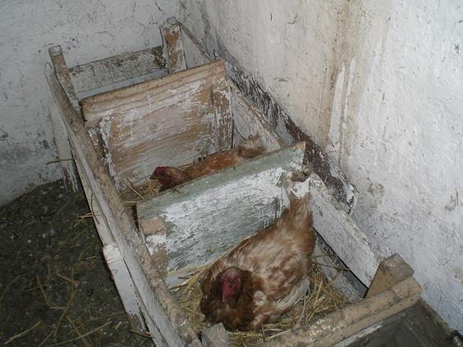
Some hens at lay

All the hens should soon start laying again in early spring and a new electricity line has been installed to the hen house to ensure the hens get at least 12 hours of light to help encourage them lay. More pullets are planned to be purchased in spring to increase the hen flock. Last year Chynara found it very easy to sell surplus eggs through nearby shops and profitably so hence the plans to increase the flock.

The vegetable crop, particularly the potato crop was very disappointing in 2010 and no funding of a vegetable garden is being considered for 2011 as funds provide a much better return from the livestock projects. The apple crop during 2011will be minimum following the replanting of the apple orchard in 2009; 2013 will probably be first crop from the replanted trees. The black current bushes were pruned back considerably during 2009/2010 so hopefully the new growth will result in a good crop in 2011, assuming there are no late frosts like last year. Jam making continued to be a major activity during summer 2010 using their home-grown berries and those provided by others. Over 90 litres of jam was made, including 20 litres of raspberry jam, 30 litres of blackcurrants, 15 litres of cherry and 25 litres of apricots.

Projects under consideration for 2011
- Ongoing operation costs
- Purchase of replacement animals for those that will be sold in the spring
- Expanding the hen flock
- Study Room – more chairs and 3 storage units still to be financed.
- Signage outside the orphanage and other signs on nearby roads

Caution is being used regarding expenditure as we like to have some funds in reserve for any unforeseen expenditure and also because of Hugh’s recent illness and our fundraising events are put on hold until he has recovered.

The new telephone for the orphanage is 03922 53815 and for those of you living in, or perhaps even visiting, Kyrgyzstan and would like to visit the orphanage – please ring Chynara and confirm a date and time that suits. The address of the orphanage is 19 Tret’yakevich Street, Karakol (landmark - turn right at the massive heating plant and third house on left).

Micro Credit
The two Microcredit Projects have had varying degrees of success during 2010: ICK activities continued to expand with additional funding of Euro 2300 provided whereas Tumar Microcredit has downsized as the two part-time managers were made unemployed from their other jobs in 2010 and may have to move away from Karakol to find employment. Since they became involved in Tumar both these managers have got married in recent years and now have kids, so they have limited time to support microcredit activities and have returned funds during the year of Euro 2300 so the funds are down to a size they can manage.
Congratulations to Arsen (manager of Tumar) on birth of his second child, Emil, in December and to Kuba on the birth of his first child, Islender, in January.

At any one time during the year the two schemes funded between 50 and 60 clients. Since the start of these initiatives, Tumar in May 2007 and ICK in October 2007, a total of Euro 12,950 has been provided to the two schemes, Euro 6,050 to Tumar MicroCredit and Euro 6,900 to ICK (which focuses on women).

Karakol Micro Business Fund – Tumar
At the end of 2010 Tumar had 23 microcredit clients, 17 having business loans and 6 having social loans, the latter being on easier terms. Typically Tumar provide loans to small kiosks selling groceries, grocery shops, livestock and crop enterprises, small businesses such as glasses or mobile accessories, fast food outlets, and trading businesses.

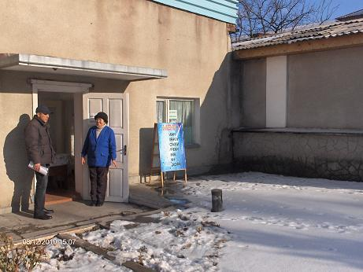
Arsen with Tumar restaurant client

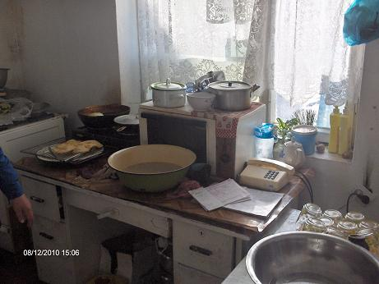
Kitchen preparations of Tumar fast food client

Karakol Micro Business Fund – Social Fund MicroCredit Agency “Development”
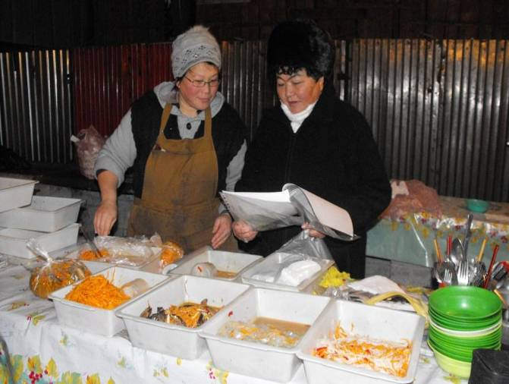 Sonun, Director, with new client preparing traditional cuisine

By the end of 2010 the “Development” MicroCredit Agency typically funded 28 clients with total loans of 429,826 som, or approximately15,300 som per client (approximately Euro 250).

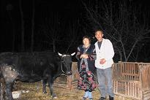
Lady client with her newly purchased cow

The types of activities funded were quite diverse and included: sewing/knitting, trading in agricultural and industrial products, milk production, rearing calves, sheep breeding, poultry production, crop production (including garlic), transport, bakery, manufacturing of stoves and plastic windows, traditional cuisine and perfume sales.

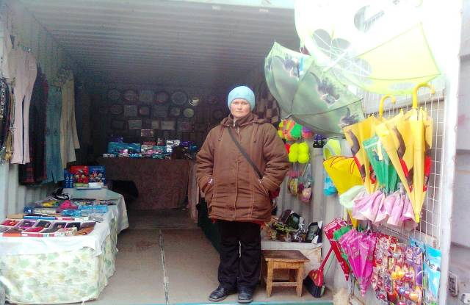
Client selling souvenirs and toys
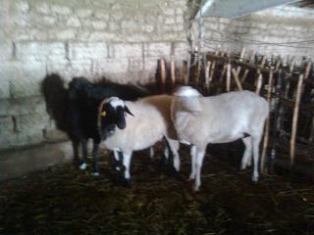
Funding of breeding sheep

Bermet, Chynara’s daughter, in Turkey
In our last edition of the Newsletter we mentioned that Bermet, one of Chynara’s daughter who has been not only helping to look after the children over the past 6 years but has also acted as interpreter for our visits over the past number of years, won a 10 month scholarship to study at a university in Turkey. We supported Bermet with some funds to tide her over until she received her scholarship. Bermet has been studying very hard at university but presently is on a two week break and has taken the opportunity to visit Cappadocia with its scenic splendours and its long history of civilisation, including underground cities in the volcanic rocks. She had an exciting time visiting museums, the bazaar and jewellery markets.

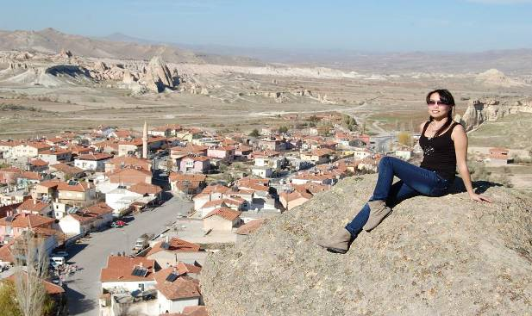
Bermet enjoying the sights of Cappadocia

Earlier the Kyrgyz Embassy invited Kyrgyz students who were studying in Turkey to celebrate the New Year at a restaurant in Ankara. Bermet had thus the opportunity to meet with other students from different parts of Turkey and exchange experiences.
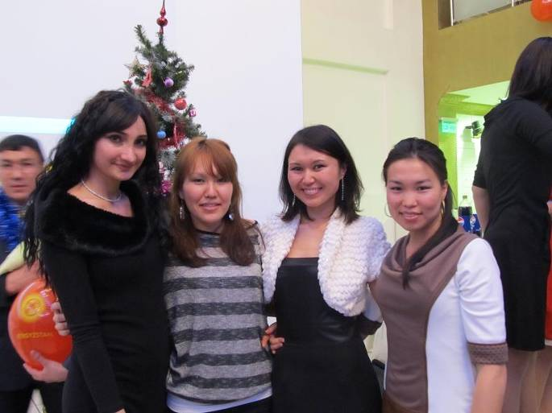
Bermet celebrating New Year with fellow students
Last word
Hugh started a new two year project in Kyrgyzstan last October but he returned to Ireland late November for an operation but plans to be back in Bishkek at the beginning of April. Thus we will have another 18 months to build on the sustainability of all Karakol Projects.

Thank you once again to all who have continued to support us as well as our new sponsors to these very worthwhile humanitarian projects. Your contributions really do make a world of difference to the kids and to our microcredit clients

Contact Details
Further enquiries and details can be obtained by Emailing: hugh.coulter@gmail.com or
Writing to: Hugh & Jean Coulter, Mourne View, Coolfore, Monasterboice, Drogheda, Co Louth, Ireland or
Telephoning: 353 (0) 41 9826819
Mobile: 353 (0) 87 2740607
Bank Details Bank A/c: Karakol Orphanage A/c
Ulster Bank,
104 West Street, Drogheda, Co. Louth, Ireland
A/c No. 13403018
Sort code: 98-55-65
BIC: ULSB IE 2D
IBAN: IE03 ULSB 9855 6513 4030 18

