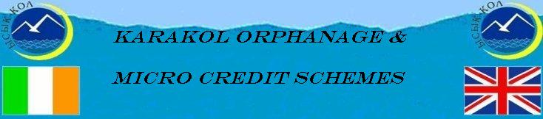

Update January 2010

Introduction
Belated Happy New Year to one and all and it seems appropriate for this edition of our bulletin to review our activities during 2009 and to outline some of our plans for 2010. First and foremost we would like to thank all our sponsors and donors, both international and local, for their generosity during 2009. During 2009 with your help we raised Euro 11,292, and together with carryover funds from 2008 a total of Euro 17,297 was available for Orphanage and Microcredit activities. We would like to give special thanks to the Navan Lions Club for their continued support to making the orphanage more sustainable through expansion of the livestock project, to Ian Claytor of Celestial Mountain Tour Company for his regular donations, to KMK Metal Ltd, Kurt and Edeltraud and our ‘French Connection’ of Nicolle, Joelle and Denis for their ongoing generous support, to the Intrepid Hikers for their additional funds received in 2009 from their Pyrenees trek, to Marie-Ann and Nyugen who requested their wedding guests to donate funds to the orphanage in lieu of wedding presents, to our numerous supportive relatives, friends and colleagues for their amazing generosity. We are also very grateful to local sponsors and donors in Kyrgyzstan, specifically the International Women’s Club, and Kumtor and the Tien Shan Fund for their continued support, but also to numerous Karakol companies and individuals that contributed more often in kind in terms of roofing material, flour, vegetable oil, ‘goodies’ for the kids and such like.

Of the total funds available we allocated Euro 11,087 to the orphanage, Euro 5,702 for operating expenditure and Euro 5,385 for mini-projects. A total of Euro 3,450 was allocated to increase the funds of both Microcredit schemes, of which Euro 2,650 was allocated to Tumar Microcredit and Euro 800 to ICK Microcredit. The reason for the disparity in funding of the two schemes is the need to increase funding of Tumar to a sustainable level; ICK was an already established microcredit scheme with its own funds. In addition other expenditure of Euro 564 which included a donation to a very ill cancer patient to pay for treatment and medicines, and some minor expenses related to donation of a forty foot container of veterinary laboratory equipment, kindly donated by the National Veterinary Laboratory of Ireland. At the end of the year there was a balance of Euro 2,196 which is carried over to 2010 to continue our activities.

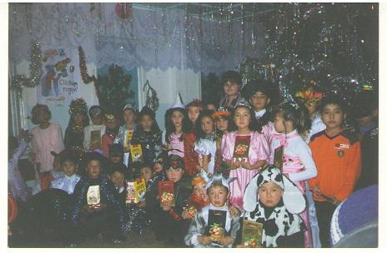
Children enjoying their Christmas Party

Highlights of 2009 were the building of hen house and establishing a hen project, the official opening of the playground and its equipment coinciding with International Children’s Day, the construction of the massive and impressive livestock building (we used to describe it as a byre but it is a building for all types of livestock – cows, calves, sheep and goats) and thus facilitating the expansion of the livestock project, and funding over 100 microcredit clients during 2009.

Jean organised a trip to Karakol and Bishkek for three of her good Irish friends – the Ladies Mountain Hikers and apart from climbing mountains they also spent some time visiting the orphanage and microcredit schemes, and experiencing the incredible hospitality of our Kyrgyz friends, Chynara and Sonun in particular.

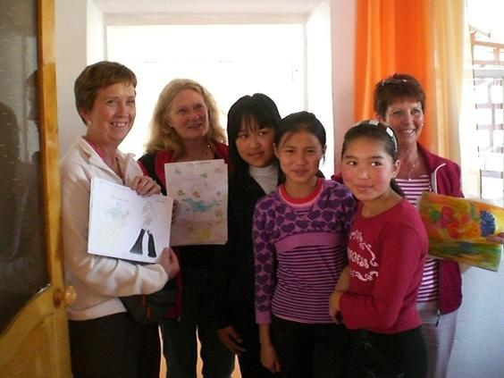
Jean’s friends – the Mountain Hikers – being presented with paintings by the kids.

Date for Your Diary

Fundraising Event 2010



IT COULD BE YOU!!!!!!
DATE IN MAY TO BE ANNOUNCED ONCE WE HAVE YOUR COMMITTMENT
Email jean @ jean.coulter@gmail.com
Global Skydiving Day –
It is getting more difficult to come up with fresh, fun, challenging ideas for fund raising but we feel that this may tick many boxes.
We have been in contact with the Irish Parachute Club, based in Edenderry, Co. Offaly and have agreed a fee for tandem skydiving. We want to hold this event on a Saturday in May, 2010. The club can cater for 50 – 60 jumps per day. Can you help? Will you jump?

Our target is to have 60 jumpers raising €560 each, €260 to pay for the jump fee and €300 towards Karakol project funds. Hopefully about €18,000 will be raised.

We need names and €260 for each jumper
by 31 March 2010.

In addition we are aiming to get jumpers in as many continents as possible to make this a truly global event. Friends and Family in Australia, New Zealand and South America have shown interest already. Let’s see if we can add some more interesting places to the list!!!!

Please pass this newsletter on to anyone you think might be interested – inside many of us there is that secret desire to do something new, exciting, even crazy!!!!!!!

Karakol Orphanage

The success of our Karakol Orphanage activities is due to two factors, the first being the wonderful care and administration of Chynara and her amazing band of volunteers, most of whom are family and relatives, and the second to the generosity of our sponsors and donors. In this edition we would like to report on how the funding was spent in 2009. Of a total Euro 11, 087 funding to the orphanage Euro 5,702 (51%) was spent on operational expenses and Euro 5,385 (49%) on mini-projects. The major operating expense was food Euro 3,396 (60%), followed by medication Euro 660 (12%) (for epilepsy treatment of Jyldyz), electricity Euro 321(6%), telephone Euro 224 (4%), washing/cleaning items Euro 251 (4%), gas Euro 151 (3%) and miscellaneous Euro 697 (12%) (includes school items like bags, pens, notebooks, as well as transport).

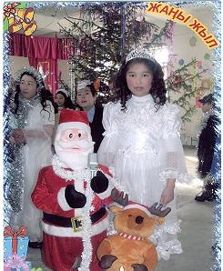
Jyldyz starring in her school play – it is obvious her
epilepsy treatment is certainly helping –
Jyldyz has not had an episode in over 2 months

In terms of mini-projects of Euro 5,385, the major expenditure was Euro 2,496 (46%) on the livestock building, followed by playground and equipment of Euro 1,193 (22%), hen project Euro 856 (16%), potato project Euro 192 (4%), hay production Euro 208 (4%), lamb project Euro 175 (3%) and other of Euro 265 (4%) (including purchase of 12 chairs, transport of 40 boxes of kids clothes and Toefl books and exam).
There are now 21 children at the orphanage, five additional children were brought to Chynara in January due to family problems. The Karakol Orphanage caters for between 10 and 25 children on a temporary basis as the objective is to get the children returned to their families or extended families. Since the orphanage started it has catered for 250 children in this manner.
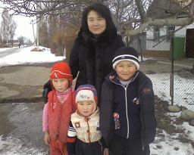
Three of the new children with Bermet, one of the Volunteers
The children are enjoying the huge amounts of snow this winter and every Sunday Chynara and family take them on day trips to enjoy activities on snow and ice.

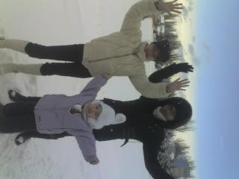
Medina, Saida and Aisat
Enjoying a fun day out in the snow

It is noticeable that the number of children taken into care over the winter period always increases as very poor families struggle to survive the harsh winters.

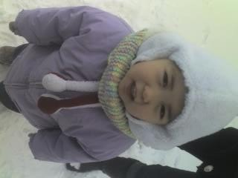
Medina all wrapped up!

Kumtor Gold Mine provided lots of winter clothing and funds to pay for New Year party for the children. Many thanks for your continued support.

Progress on Sustainability

Hens are due to start laying early spring, they have been checked by a vet and their condition appears to be fine. Additional lighting has been provided in the hen house to aid the onset of laying. We are hopeful that 130 layers will add significantly to the children’s dietary needs and also provide additional funds towards our sustainability goal.

The huge livestock building is now completed however, the security wall is not yet constructed though the foundation has been laid. The delay is due to the builder being in hospital just before the winter and now with weather conditions so bad it has been impossible to finish. All materials are purchased so once the spring arrives work will be finished.

Kumtor have promised two cows, so we are hopeful that they will be delivered soon and this should contribute significantly to sustainability.

Five tons of potatoes were recently sold and the funds thus raised were used to purchase coal for the winter.

Projects under consideration for 2010
- Ongoing operation costs
- Purchase of more animals
- Study Room – more chairs and 3 storage units still to be financed.
- Signage outside the orphanage and other signs on nearby roads
- Purchase of suite of furniture for the playroom
- Two solar systems to reduce electricity and heating bills
Caution is being used regarding expenditure due to our ongoing concerns regarding finance of food requirements and medical costs for Jyldyz & others.

Micro Credit

Microcredit activities continue to expand and at any one time during the year the two schemes are funding between 60 and 70 clients. Since the start of these initiatives, Tumar in May 2007 and ICK in October 2007, a total of Euro 12,450 has been provided to the two schemes, Euro 7,850 to Tumar MicroCredit and Euro 4,600 to ICK (which focuses on women). During 2009 Euro 2,650 was provided to Tumar and Euro 800 to ICK. As mentioned above our present emphasis is to increase the funding to Tumar until it reaches a level to ensure its sustainability.

Karakol Micro Business Fund – Tumar

Since Tumar Microcredit has been established in 2007 it has funded 161 clients with about 11,000 som (Euro 200) per client. Businesses funded included 5 crop production, 5 livestock production, 5 meat processing, 2 internet services, 30 catering and cafes, 85 shops (working capital mainly for stock), 3 taxi services, 4 computer services, 14 bakeries, 3 banya (sauna) services, 1 carpentry, 1 building, 1 flat service and 2 consumer services.
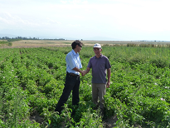
Kuba with Potato Production Client

At end of January 2010 Tumar had 36 clients, 21 under its business line and 15 under its social line (longer term and lower interest rate). The continued success of this microcredit scheme is due to the excellent supervision of Kuba and Arsen and their local knowledge.

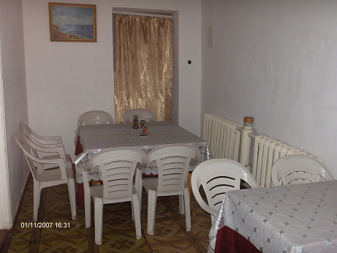
Client’s Small Cafe
Karakol Micro Business Fund – Social Fund MicroCredit Agency “Development”
Under the management of Sonun and her capable staff, during 2009 the “Development” MicroCredit Agency typically funded 22 clients with total loans of 321,180 som, or 14,600 per client (approximately Euro 240).
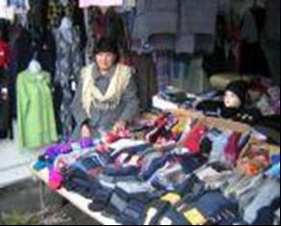
Client displaying her range of Knitting Ware

The types of activities funded were quite diverse and included: sewing/knitting (4), trading in industrial products (5), trading in agricultural products (6), rearing livestock (2), agricultural production (potatoes & garlic) (3), transport (1) and bakery (1).
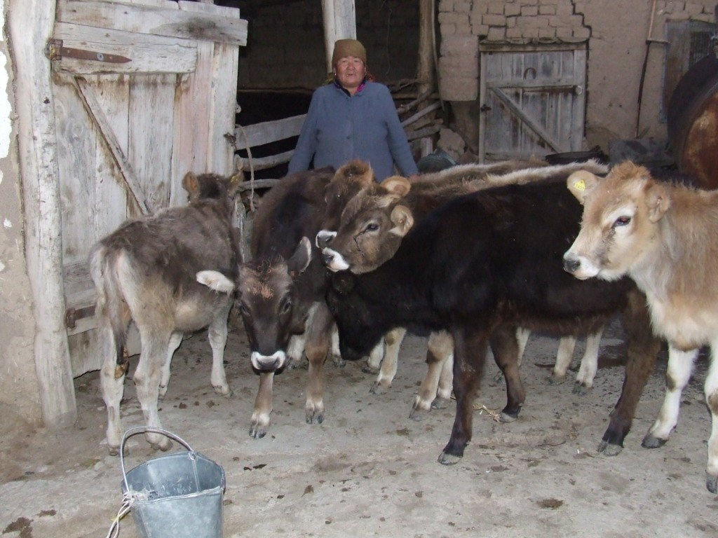
Calf Rearing & Bakery Enterprises

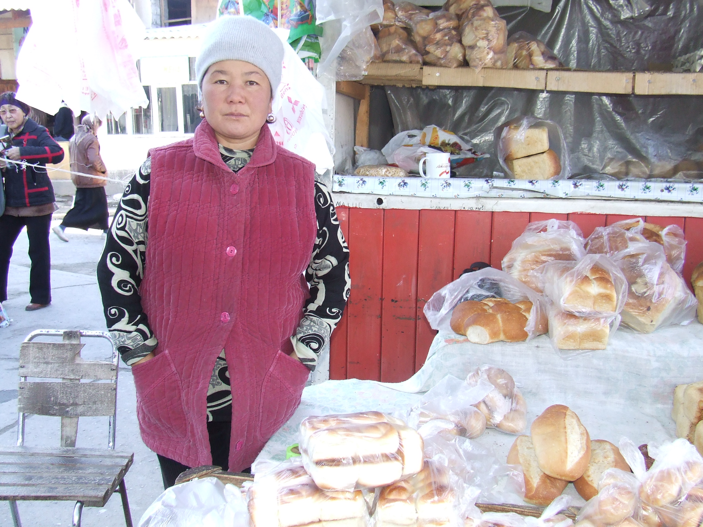
During 2010 Sonun is planning to diversify her credit portfolio into funding artificial insemination of cows, veterinary and agricultural services, recycling, hot house systems for fruit and vegetables, small-scale agro-processing and drip irrigation systems.

Last word
Hugh is now returning to Kyrgyzstan for another project so we will be back on the ground in March. This will give us another year to build on the sustainability of all Karakol Projects.

With your help we can make 2010 an even better year for the Children and so many people who rely on the funds from the MicroCredit Projects.
Please try to promote our SkyDiving Event.

We would like to thank all who have continued to support us as well as new contributors to these very worthwhile humanitarian projects. Without you all none of this would be possible.

Wishing you all a happy and peaceful 2010.

Contact Details
Further enquiries and details can be obtained by Emailing: hugh.coulter@gmail.com or
Writing to: Hugh & Jean Coulter, Mourne View, Coolfore, Monasterboice, Drogheda, Co Louth, Ireland or
Telephoning: 353 (0) 41 9826819
Mobile: 353 (0) 87 2740607
Bank Details Bank A/c: Karakol Orphanage A/c
Ulster Bank,
104 West Street, Drogheda, Co. Louth, Ireland
A/c No. 13403018
Sort code: 98-55-65
BIC: ULSB IE 2D
IBAN: IE03 ULSB 9855 6513 4030 18

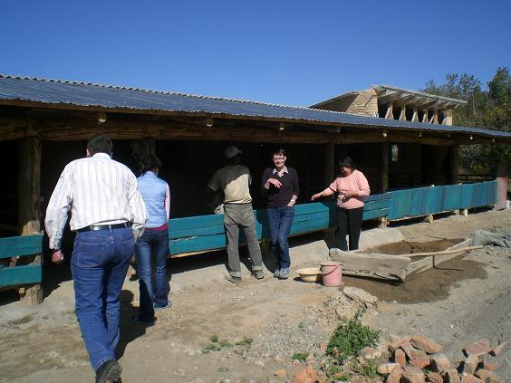
The Orphanage’s new Livestock Building.

